Internet of Things Project

Table of Contents

1. Introduction 3

2. Detail Case Study Analysis and its Solution: 3

2.1 Addressing the task given in the case study: 3

2.2 Identifying three business improvements can be done to improve Smart Farming Solution: 5

2.2.1 First Business Improvement: 5

2.2.2 Second Business Improvement: 6

2.2.3 Third Business Improvement: 6

2.3 Suggestion of three new sensor data elements in the smart farming: 7

2.4 Alternative designing of a IoT network using the givens sensors and gateway, without using TTN as a middleware application server: 8

3. Step-by-Step Process and explanation about the project usage and configuration with screenshots: 8

4. Difficulties Faced 18

5. Conclusion: 20

6. References 20

# Introduction

This report gives us the information and idea regarding how the Internet of Things (IoT) is contributing to the agriculture sector, which helps the farmers to do smart farming using the current smart technologies so that they increase their productivity and efficiency by managing the crops, agricultural land, other tools, and resources used in the farming. The IoT sensors are used to gather the data from the agricultural field, but this data needs to be processed and stored in the database and before take any further action on the gather information it should be presented somewhere in the form of statistics or graph for this there any many tools and software available in the market but here, three main web application-based software are used:

* Node-red: Node-red for taking the real time data from sensors. After collecting the data node-red modules and functions are used to decode it and on the later phase it will be inserted into the database.
* InfluxDB- The influxDB is the database is used for storing and classifying the data. The data will be stored in the InfluxDB bucket.
* Grafana- It is a IoT dashboard will give the visualization to the data by querying and displaying in the various format like line or bar Graph, etc. It will also help the user to make the decision and action can be taken accordingly based on the user decision. This platform is also capable to take the automatic action and decision based on the business condition set by the users.

Also, in this report step-by-step guidance is provided for how to configure and use the above-mentioned software’s by giving a solution of the illustrated business case study of the client who is looking to develop a Smart Irrigation farming solution for their farm by using an emerging IoT technology.

# Detail Case Study Analysis and its Solution:

In the given case study, a farmer named Ms Donna Tan wants a Smart IoT Irrigation system for farming to remotely monitor the soil moisture content and in her farm. Also, she wants the following functionalities like:

* When irrigation needs to be done
* how long it is to be done
* How much water is to be needed

As, a consultant I would like to use the flowing software mentioned above to build the project functionality.

## Addressing the task given in the case study:

**Here, I would like to address the first and second task given in the case study**. The moisture sensor is configured in such a way that it is fetching live data from the soil and in that we will analyze the soil moisture parameter from the parameters collected by the sensors to the nod-red interface. As, seen in the screenshot below:

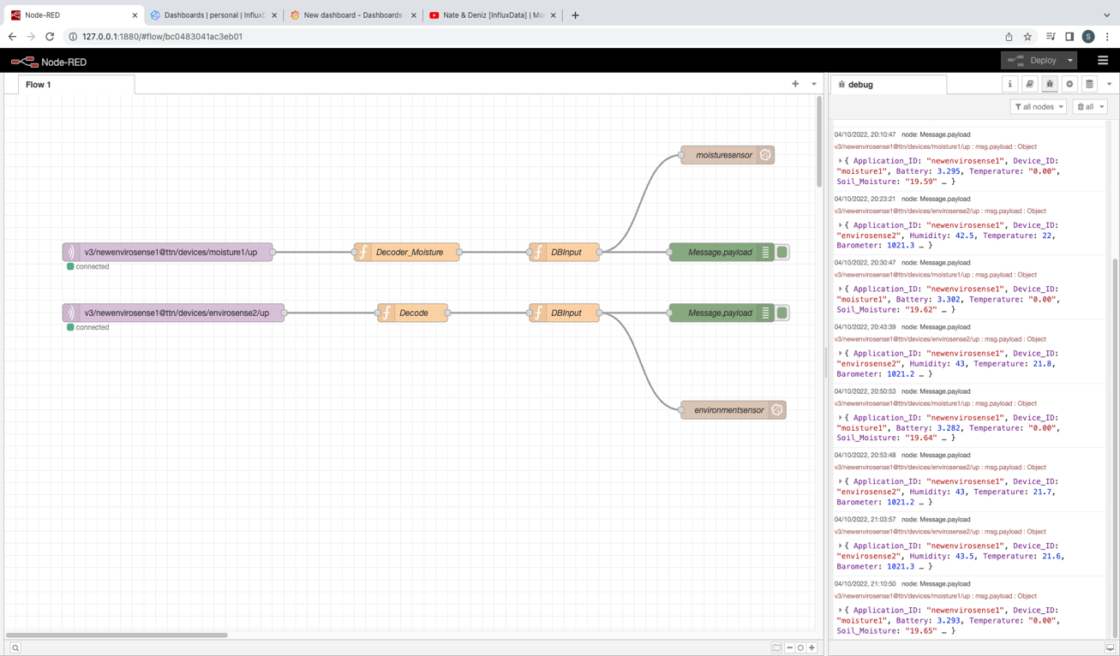

Figure 1: Node-Red Interface/Dashboard

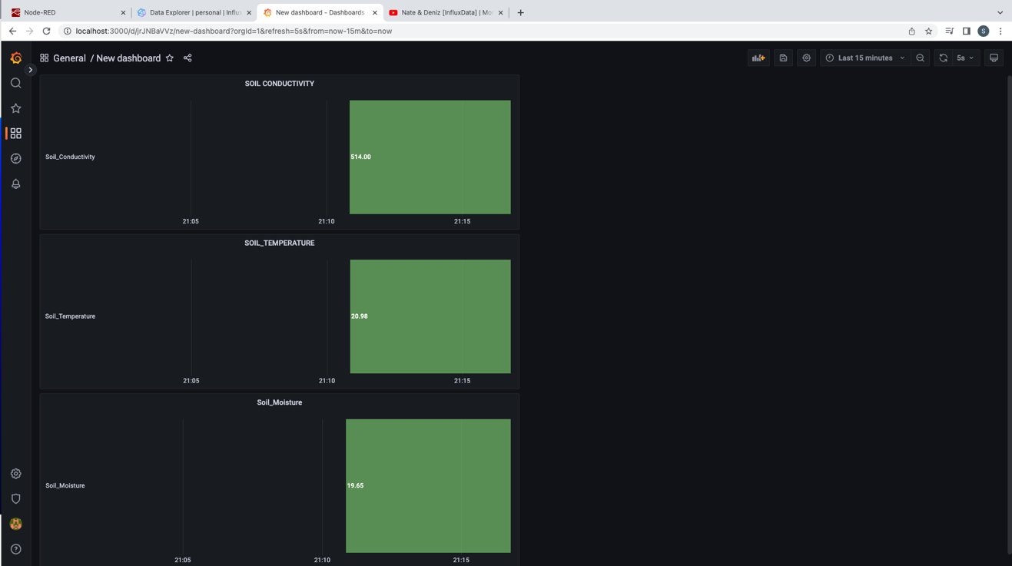

Figure 2: Grafana dashboard data visualization

From figure 1 and figure 2 the data is capture from node-red and displayed into the Grafana dashboard using InfluxDB database so that the soil moisture can be identified by the Ms Donna, and she can take a decision from it. The figure also gives additional two parameters as well which can also be helpful in deciding the current agricultural farm soil moisture level.

## Identifying three business improvements can be done to improve Smart Farming Solution:

### First Business Improvement:

* First Business improvement which I would like to suggest for making the efficient and robust use of the IoT based smart irrigation system in agriculture is to introduce the use role of Artificial Intelligence based system called Neuro-Drip which is used now-a-days in the Smart Irrigation System (Sinwar, et al., 2019). AI will control all the things related to the irrigation from data gathered by the IoT sensors, analysing the data and decision making. It will use the deep learning and neural network to analyse the crops and soil conditions by collection the different parameters like soil moisture, temperature, etc. according to that water will be given to the crops. The UAV and satellite images will also help get the images of crops and based on that also AI engines can take decisions. Also, it will save water and crops by keeping the hydration in control so that crops or yields can grow with their maximum capacity without getting failed. Also, it will help to stop the irrigation systems to get malfunctioned as it is having the inbuilt security modules in it. (Sinwar, et al., 2019)

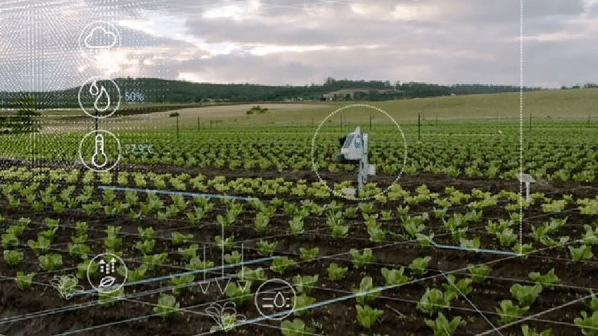

Figure (Sinwar, et al., 2019)

* By link this concept to the given case study as Ms. Donna wants the smart Irrigation system for their farm so I would like to suggest if she can implement this then it will be more beneficial for her as the AI system will do working automatically and every time, she will not have to pay attention to the system.

### Second Business Improvement:

The Drone/(UAV) based IoT smart irrigation system can be developed to do the irrigation the drones will collect the real time data and based on that the water is sprinkled on the crops as per the requirement. The drones will collect the data from the sensors deployed on the ground the sensors will transmit the following parameters to the drones like soil moisture, temperature, and the other data needed for future analysis after this it can be send and displayed at the user end for the further visualization (Mohamed Esmail Karar, et al., 2021).

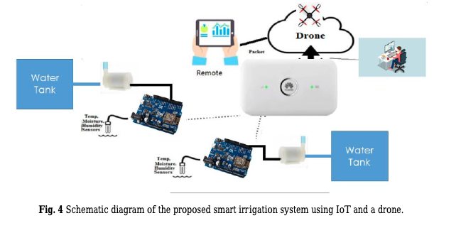

Figure (Mohamed Esmail Karar, et al., 2021)

The system shown in the above diagram will gather the data from sensors the drones will send this to cloud and the farmers will be notified after analysing the situation the farmers can decide the water quantity or let the system decide and accordingly the water pumps are operated, and water is provided. This system can be also useful to Ms. Donna which will help in their project.

### Third Business Improvement:

The third important thing I would like to discuss is to use the Energy harvesting technologies like EH sensors powered by the solar energy which will activated when needed and data goes to IoT cloud, and the Arduino Uno is used. After that the dashboard is configured to get the cloud from cloud and based on the visualization user can take the decision like how much up to what time water will be given using the pumps (Sharma, et al., 2019). So, is wireless sensors technology will be adopted by all the farmers in the future. So, this is one of the best ways we can do the irrigation by EH-IoT technology (Sharma, et al., 2019).

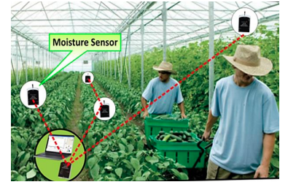

Figure (Sharma, et al., 2019)

Figure (Sharma, et al., 2019)

## Suggestion of three new sensor data elements in the smart farming:

I would like to suggest three new sensor data elements other than the elements which are collected are:

* The weather field which will tell the **weather** is sunny, windy, or rainy so the farmers can get better idea from that and from that also how much water needs to be given can be decided. I know that there is a temperature field we are getting but for the better and safer side if can have this field that from that also farmers can catch the systems errors. (For example, if soil moisture is high and it is showing still it needs the water but if they get the weather filed then they might be able to take better judgement).
* **pH level** field will indicate the soil acidic level so the farmer can get the better idea regarding the soil behaviour according to the crop conditions.
* **Sensor power (AC supply value or DC supply value)** can be shown so the farmers can get the better idea that sensors are working properly.

## Alternative designing of a IoT network using the givens sensors and gateway, without using TTN as a middleware application server:

Some companies do not like to use the TTN as a middle application server duo to various reasons like security and privacy, data processing time, etc. The solution to this is **Node-red**. This platform is having a capability to process the raw data signals directly coming from the LPWAN gateway without using TTN middleware application server. Over here MQTT server is used in this project without any involvement of the TTN middleware application server which is directly connected to the application layer.

# Step-by-Step Process and explanation about the project usage and configuration with screenshots:

I have used the MacOS for configuring this system, but it is highly compatible with both Windows and MacOS.

**Step 1**: Installed the Node-red, InfluxDB database, and Grafana dashboard first.

**Step 2**: Start the node-red server using command node-red and open the browser and type http://127.0.0.1:1800/.

**Step 3**: Start the InfluxDB and Grafana Server respectively by typing the brew services start grafana, brew services start influxdb:

**Step 4**: Run the localhost server of Grafana and influxdb by typing the following commands in the screenshot below:

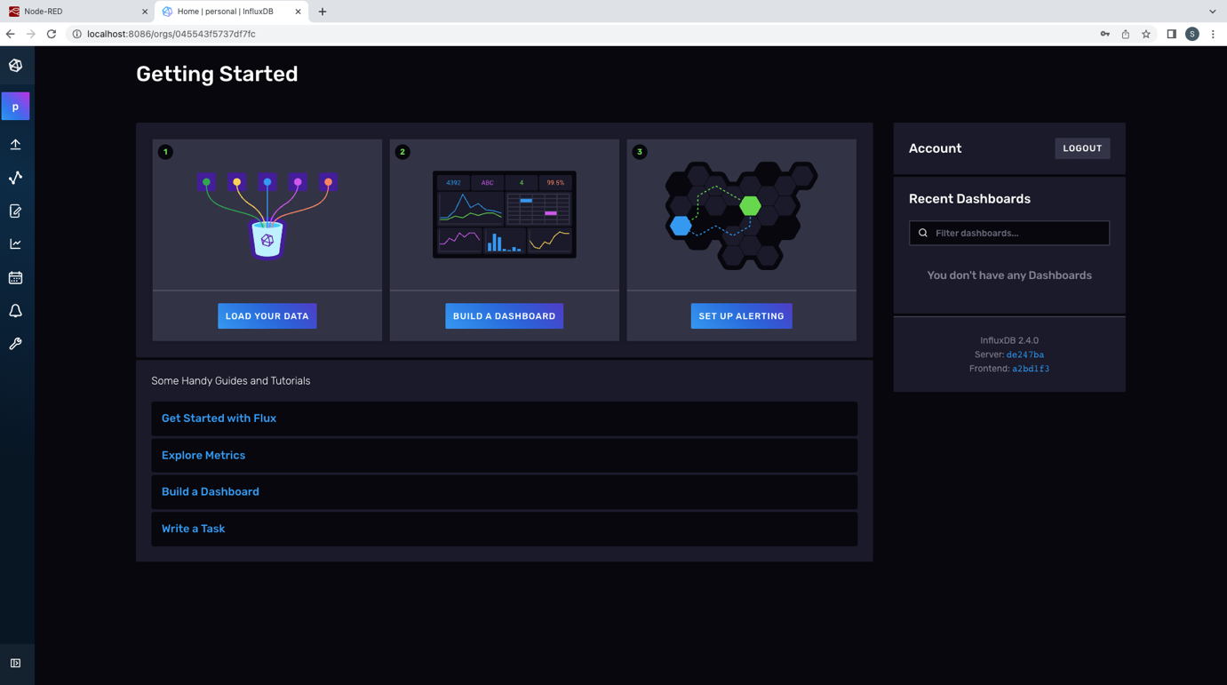

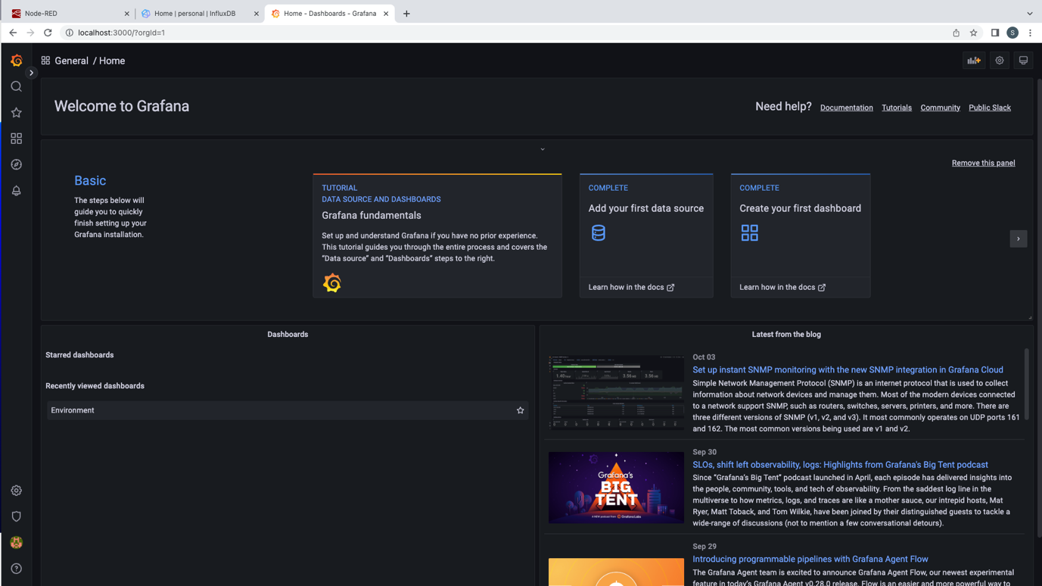

**Step 5**: Configure the two give sensors moisture and environment respectively as an MQTT node from placed at CQU campus or at the field and we will start receiving the data from the screenshot it can be seen that the data coming from the sensors are getting decoded and feed to the DB input and from DB input the connection are going to DB output of InfluxDB and debug node which shown the data in the node-red debug console.

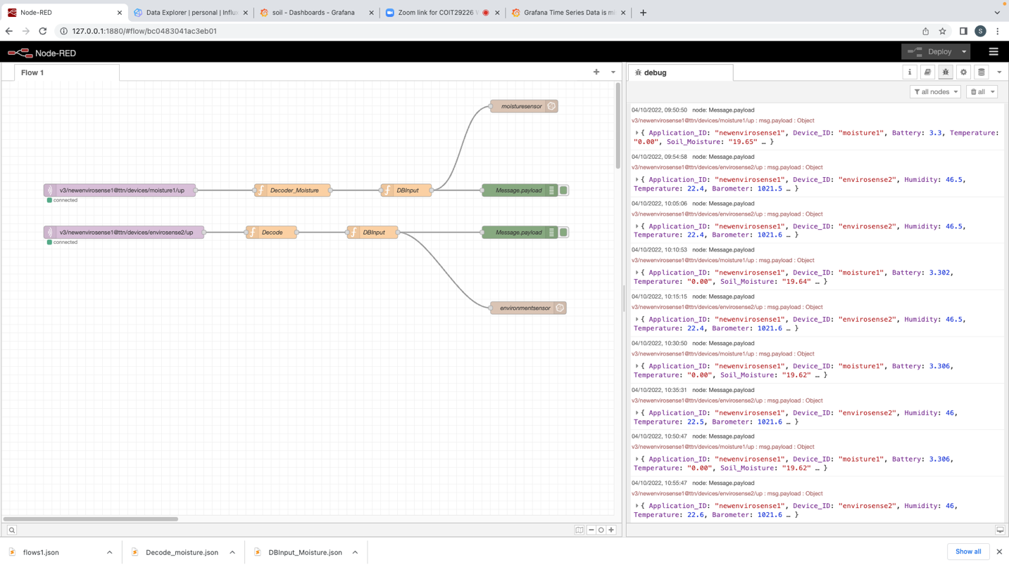

**Step 6**: After receiving the data we will configure the bucket named node-red into the Influx DB to receive and store the data coming from the node-red MQTT nodes.

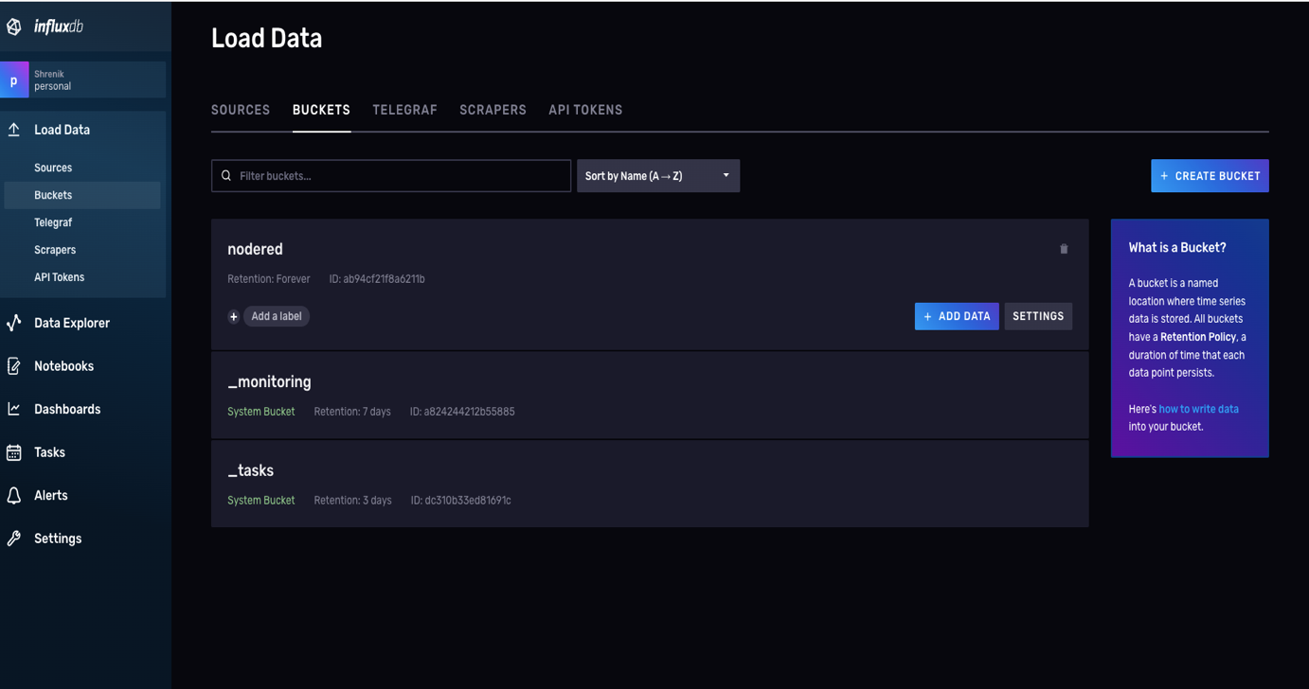

**Step 7**: After that we can see the two measured of the sensors data with the data elements. These steps are same for the moisture and environment sensors:

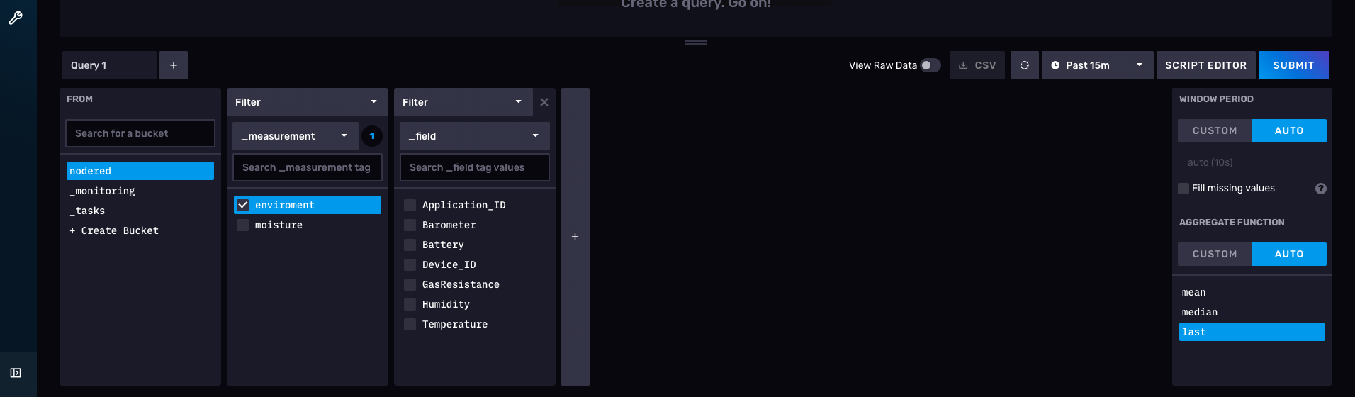

**Step 8**: After that to query the data we will use the script editor by selecting the time mean, median or last here I have selected last, these steps are same for the moisture and environment sensors:

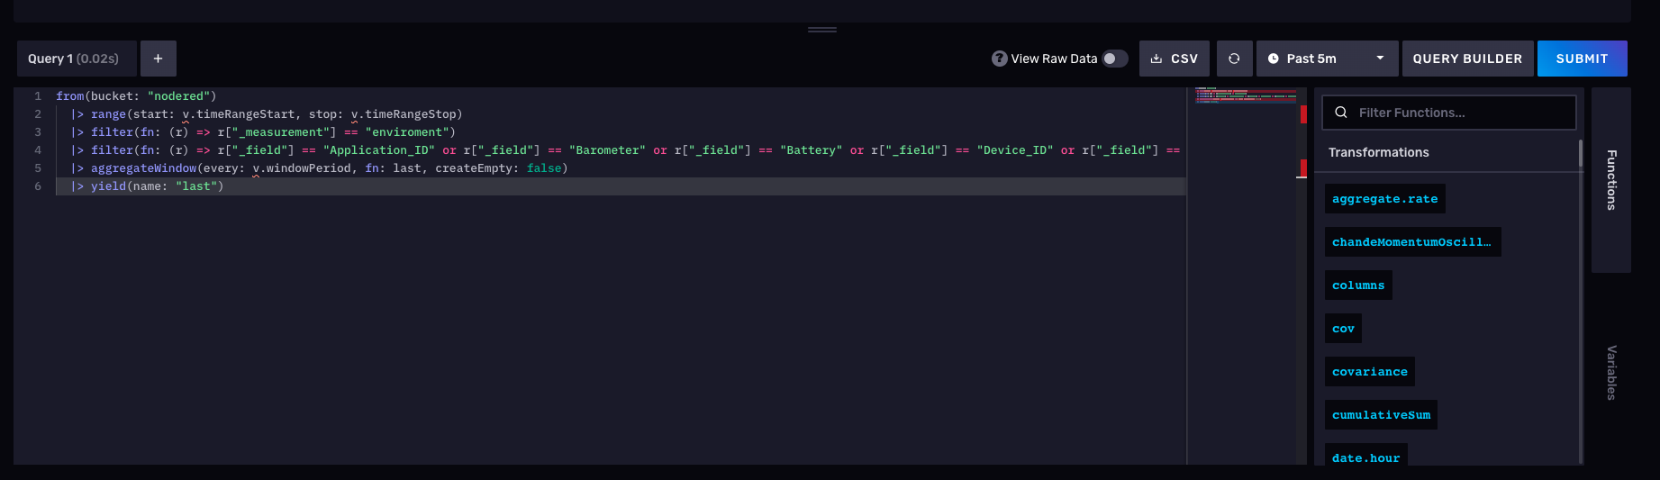

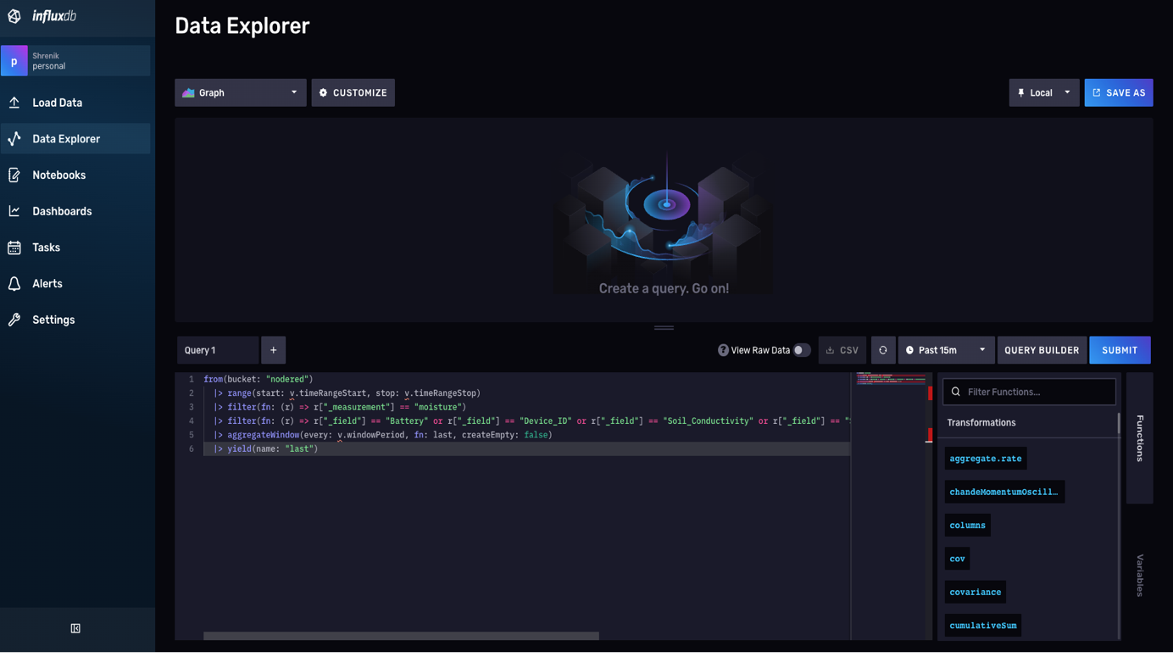

**Step 8**: Copy the selected query go to the Grafana dashboard and paste into the query by clicking on the Dashboard and add new panels:

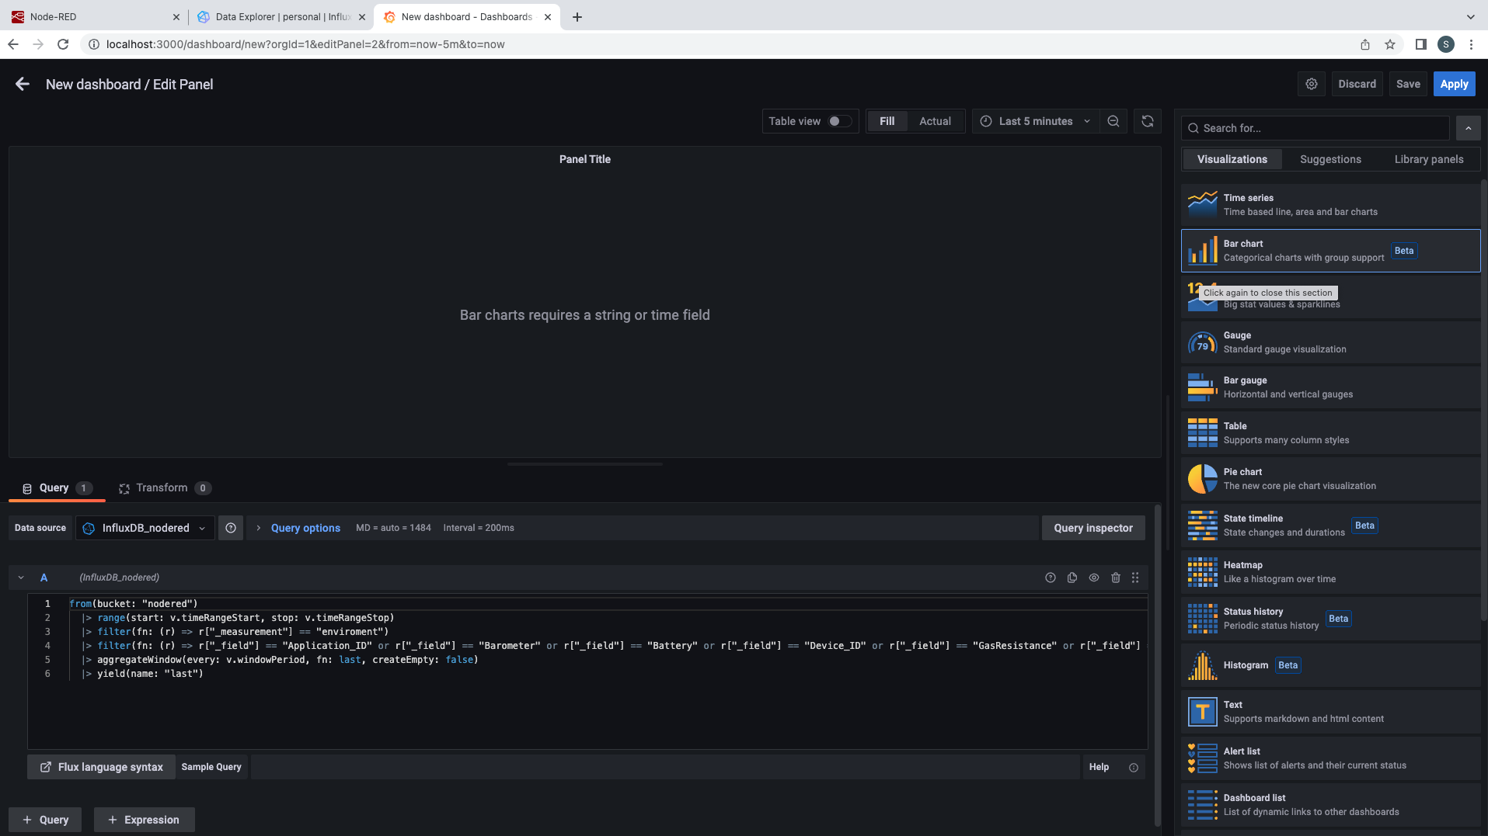

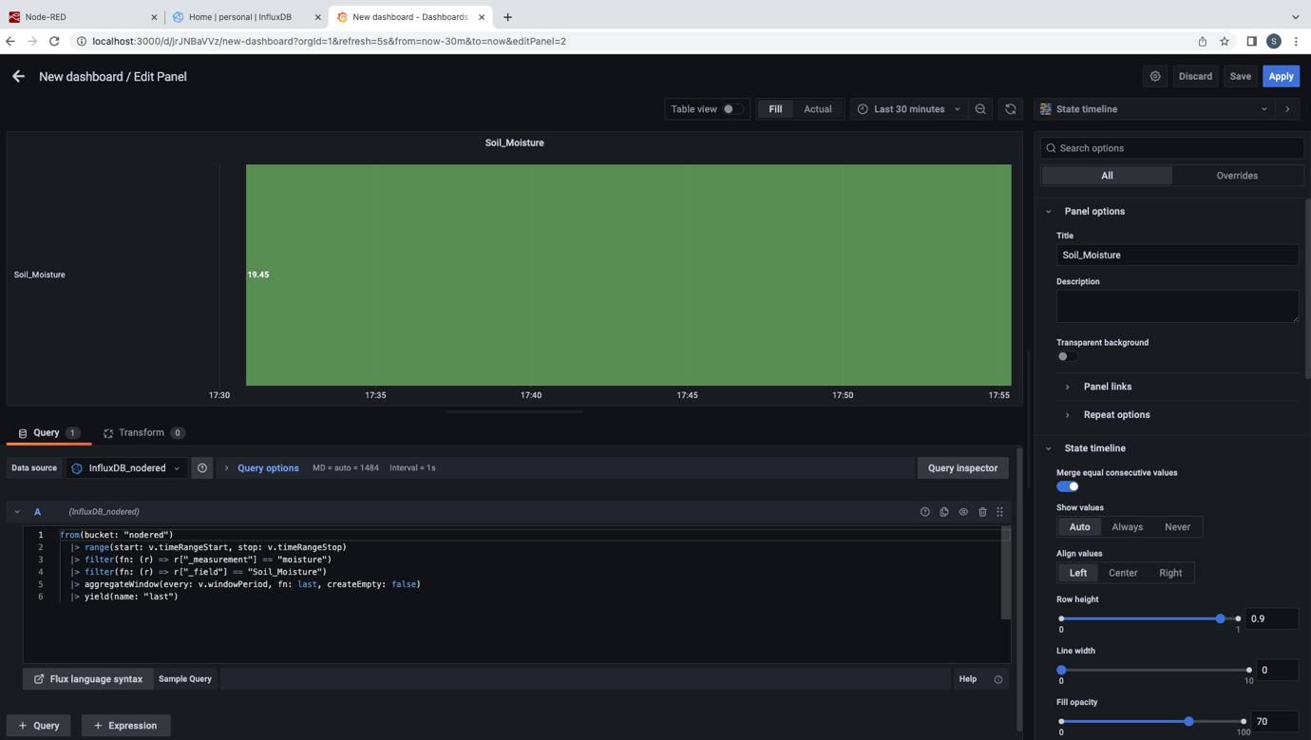

After pasting the data remove the base threshold value and select the charts/ graph as per the need and click on apply and save given on the top right corner in above screenshot. These steps are same for the moisture and environment sensors.

**Step 9**: After Seeing clicking on apply button the charts/graphs can be seen for the sensors data with the different time intervals like 5m, 15m, 1h, etc. and different types of graphical visualizations:

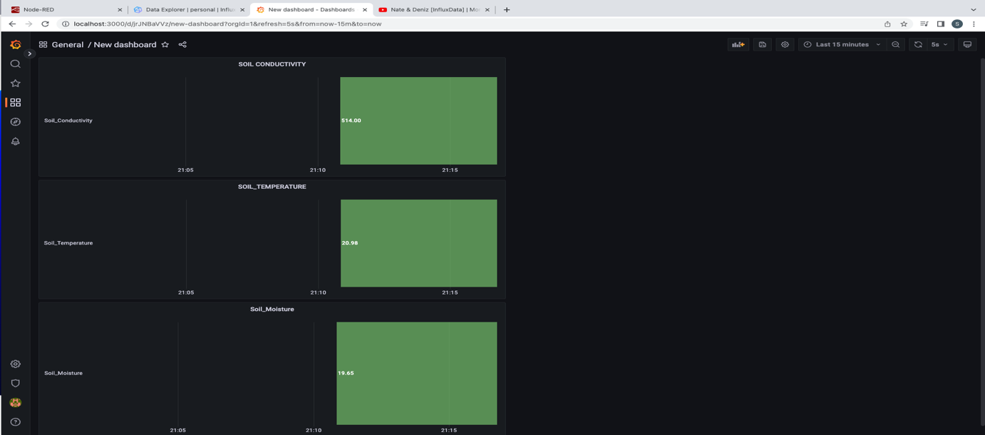

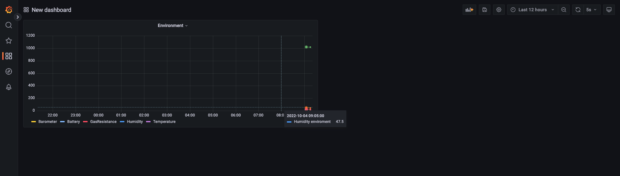

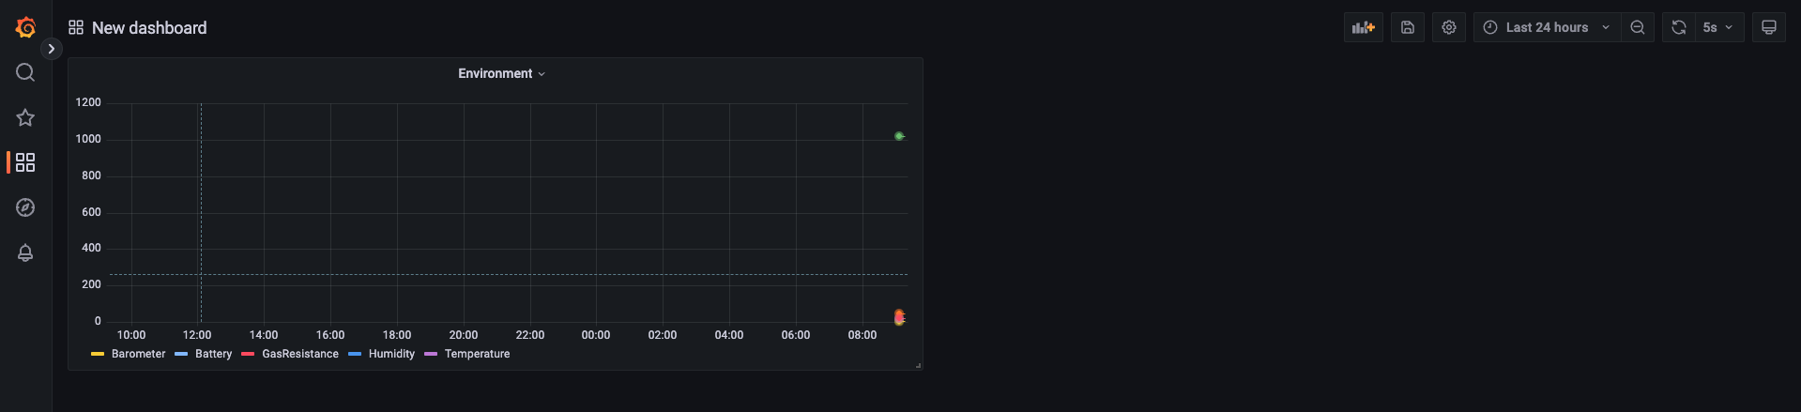

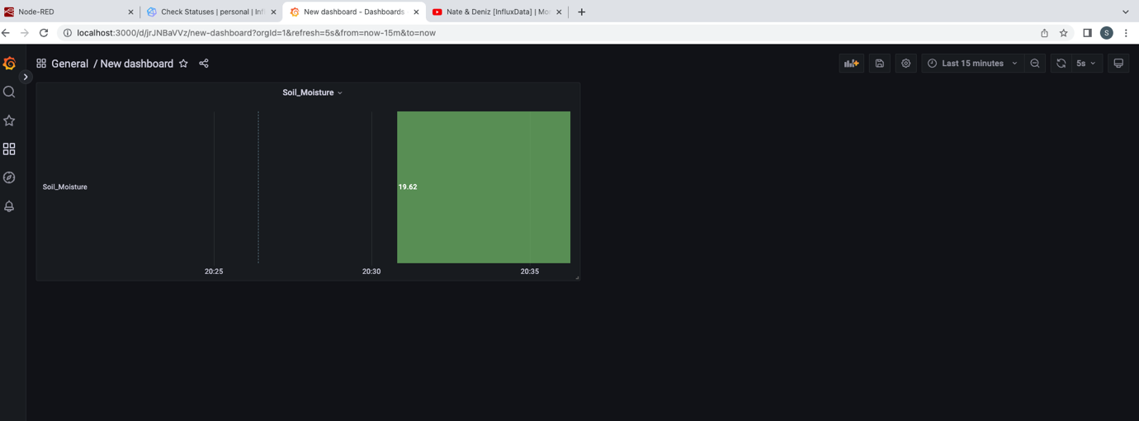

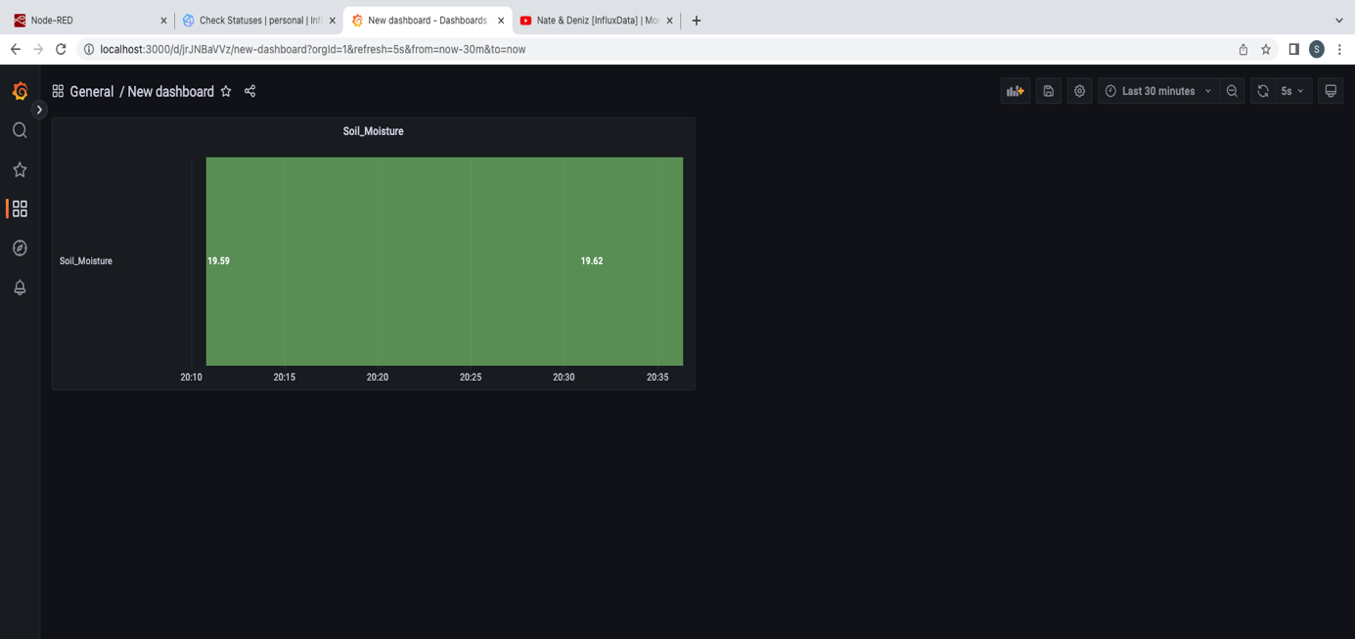

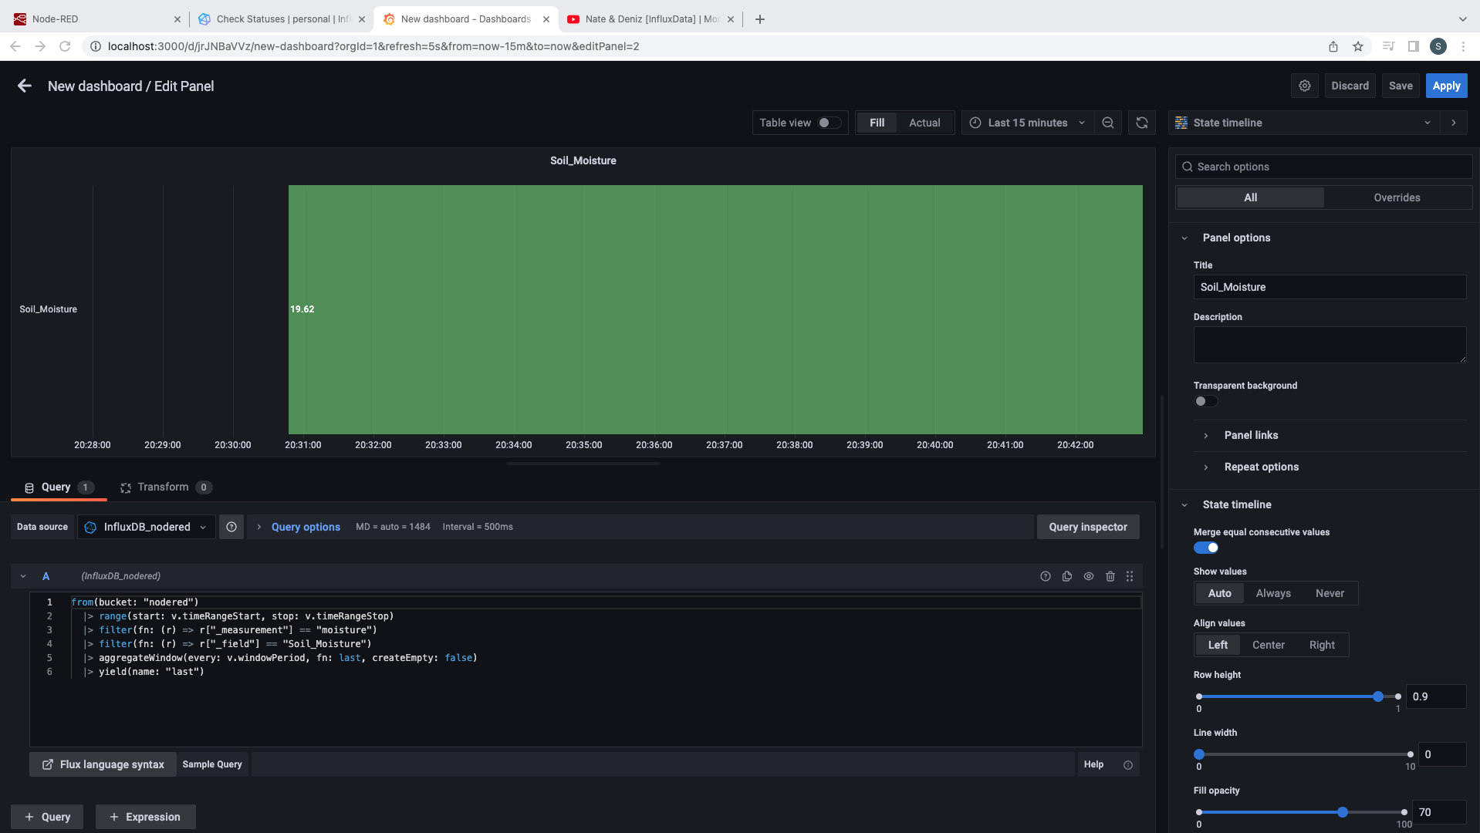

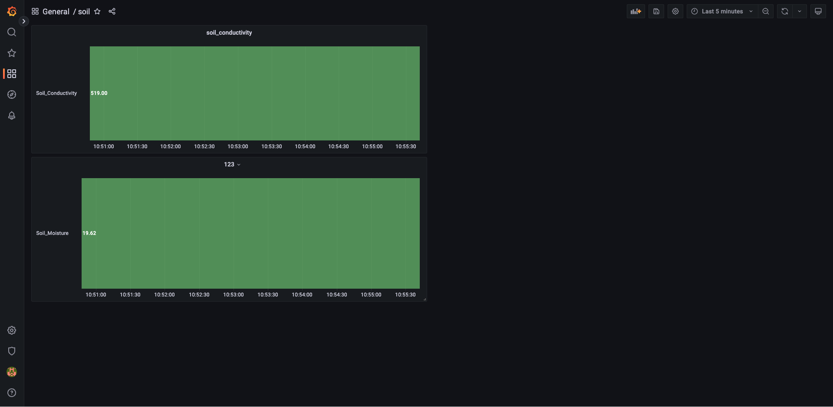

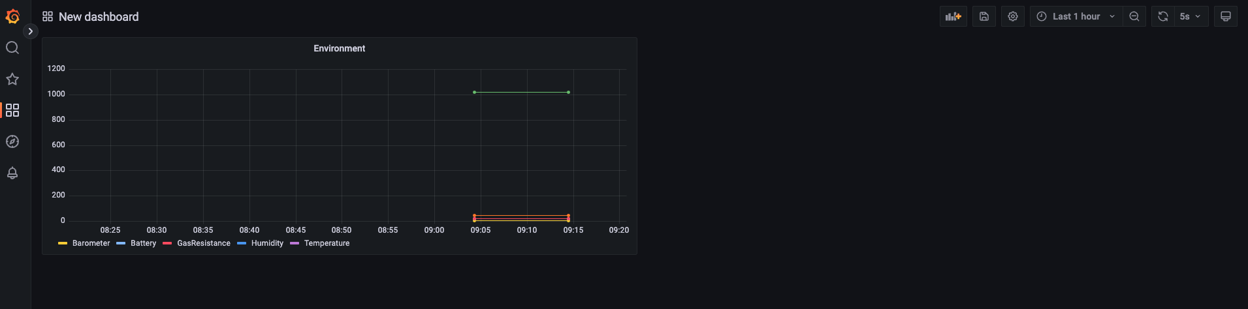

Step 10: We can also save these panels in the dashboard for the future analysis.

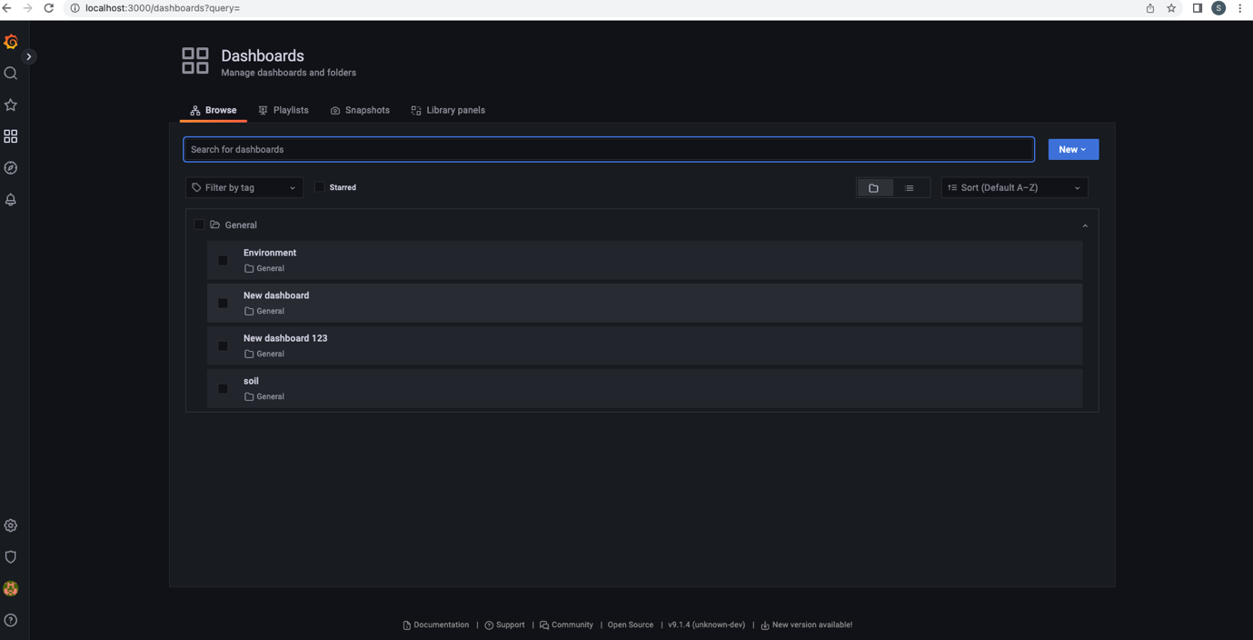

This is how all these three software’s/platforms are used and configured.

Some extra screenshots for the configurations:

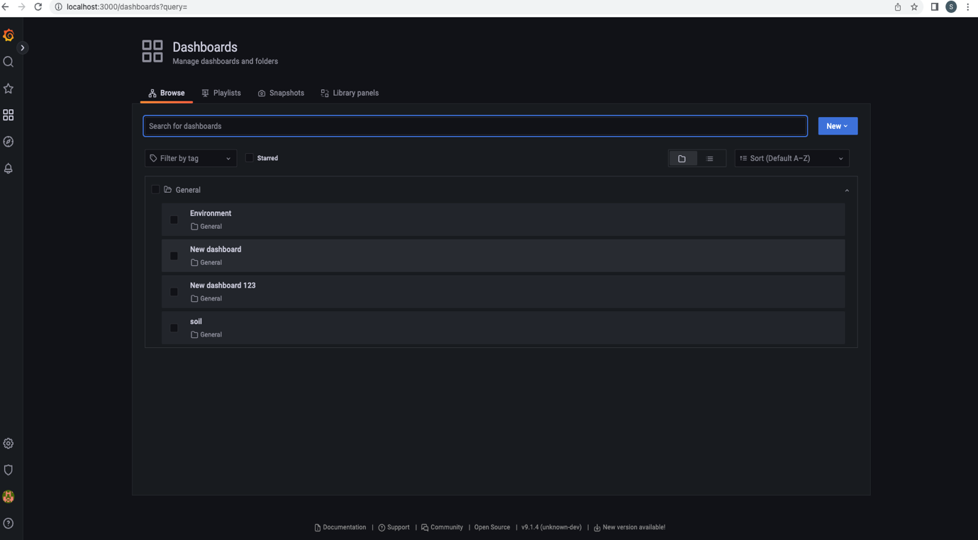

## Difficulties Faced

As the innovative works requires lots of knowledge, dedication, and research at the same time the support of the classmates and Tutors are also important. By managing all this I have tried to do the level best but there are some areas where I found some difficulties like when I created the bucked in the InfluxDB and after getting the data from both the sensors. I was facing the difficulties to show in the Grafana dashboard because when I tried to select all the

Field of the moisture sensors it was only giving the battery information only. So, after querying the data individually from the bucket to Grafana I finally managed to print the data into the Grafana dashboard.

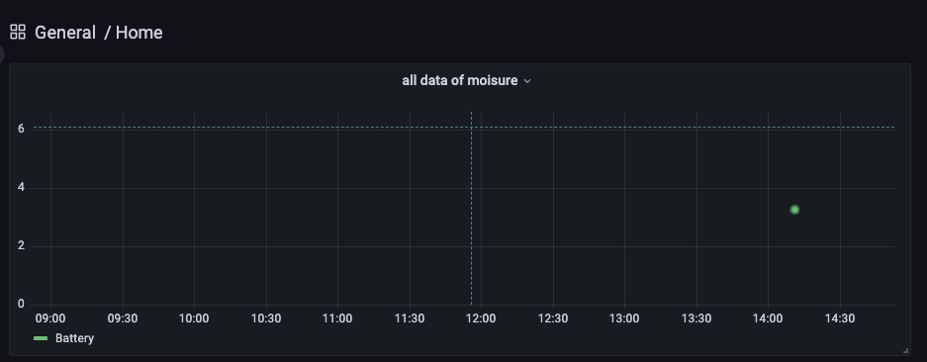

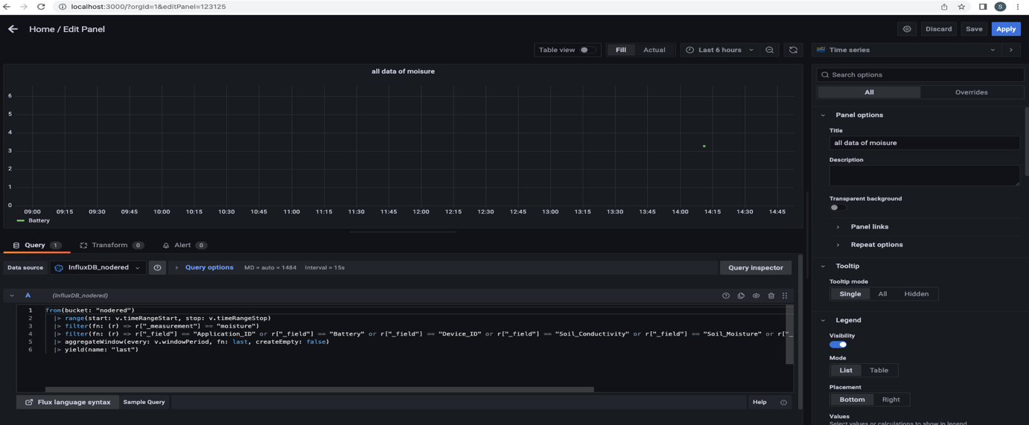

**For the future projects I would like to recommend and request that if this could be figured out then we can do more precisely. But at the end somehow, I managed to get the soil moisture sensors data by querying individually. As shown in the screenshot below:**

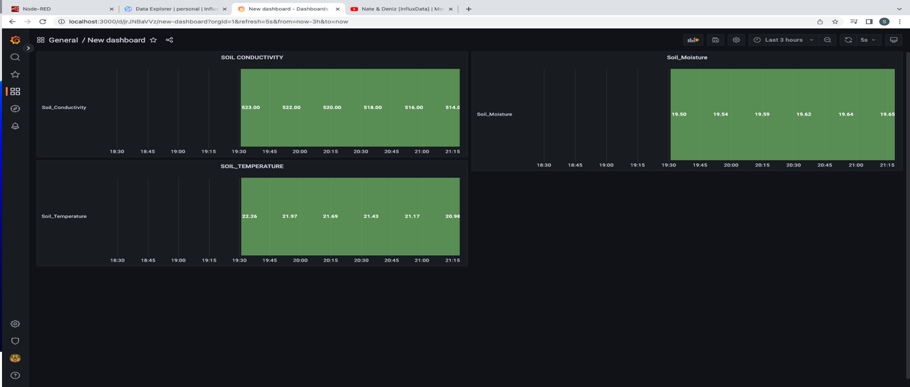

# Conclusion:

To conclude, while making this report I have learnt many things and I am sure that this will help me in my future. The platforms like Grafana, InfluxDB and Node-red are very use friendly and carries many functionalities which any user can learn while using it and provides various ways to collect and display the data. Also, while working on the Ms. Donna Tan’s project of smart Irrigation system project help me to know to make the practical implementation and use the above-mentioned software to solve the customer solution. I got some new ideas while exploring on business improvement section and on the sensors new data elements. Finally, this help me a lot as I learn to bind my practical to the theory which I had learned and the IoT is good technology to work on as it is giving its contribution in all the business sectors.

# References

M. E. K., A. A. R., F. A. & O. R., 2021. *A Pilot Study of Smart Agricultural Irrigation using Unmanned Aerial Vehicles and IoT-Based Cloud System.* [Online]   
Available at: https://www.researchgate.net/publication/348294208_A_Pilot_Study_of_Smart_Agricultural_Irrigation_using_Unmanned_Aerial_Vehicles_and_IoT-Based_Cloud_System  
[Accessed 2 10 2022].

Sharma, H., A. H. & Z. A. J., 2019. *Smart Agriculture Monitoring using Energy Harvesting Internet of Things (EH-IoT).* [Online]   
Available at: https://www.researchgate.net/publication/334729611_Smart_Agriculture_Monitoring_using_Energy_Harvesting_Internet_of_Things_EH-IoT  
[Accessed 2 10 2022].

Sinwar, D., M. K. S., G. R. & V. S. D., 2019. *AI-Based Yield Prediction and Smart Irrigation.* [Online]   
Available at: https://www.researchgate.net/publication/336819163_AI-Based_Yield_Prediction_and_Smart_Irrigation  
[Accessed 2 10 2022].